Canadian Exports to Nepal
Portable Milk Machine
Kirsten De Jong
Prof: Manish Raizada
AGR 1110
November 29, 2016

PART 1: PRODUCT INFORMATION
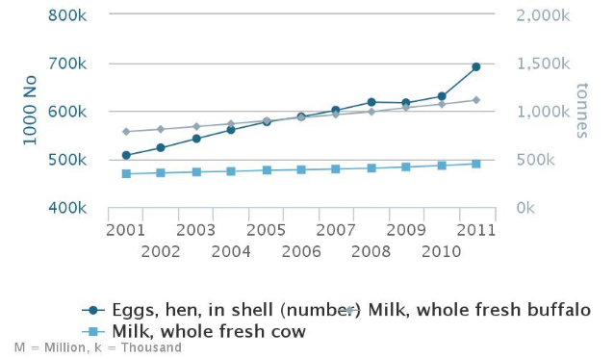
Milk production in Nepal
Improving the efficiency of milking cattle and buffalo will result in the farmers becoming more developed, more productive and the techniques will be improved. To improve the milk production of Nepal there must be more efficient milking techniques. A machine that will benefit Nepal is a portable milk machine. As seen from the graph most of the milk production comes from cattle and buffalo, therefore an improvement in milking efficiency is needed in order to keep that yield or even increase it, in order to support the increasing population.
http://faostat3.fao.org/browse/area/149/

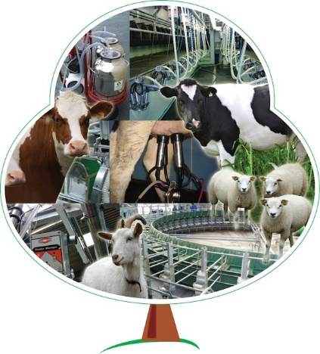
Most of the demand for dairy products such as, dairy whitener, condensed milk, skim milk, and whole milk comes from imported products (FAO, 2008). However the need for ice-cream, cheese, butter and some other dairy products come from imported and local products, also products such as paneer and yoghurt are produced local milk production (FAO, 2008). By importing the milk machine it will result in an increase of milk production because a farmer will be able to milk the cows faster which will result in more of the products in demand to be produced from local milk (FAO, 2008).

Company Supplying the Product
GreenOak Dairy Equipment is a company located in Kitchener Ontario, which is approximately 30 minutes south west of Guelph, Ontario (GreenOak Dairy Equipment, 2015). To reach GreenOak Dairy Equipment for the milk machine contact the number 1 519 342 1427 or visit them at 8 Sereda Road Kitchener, ON H2H 4X7
https://www.google.ca/search?q=greenoak+dairy&espv=2&source=lnms&tbm=isch&sa=X&ved=0ahUKEwiP9a_C9c7QAhXK5oMKHQIADa4Q_AUICigD&biw=1366&bih=662#imgrc=SwxObs6aSoWAfM%3A
(GreenOak Dairy Equipment, 2015). They have a very large product line, which can provide a dairy farmer products for milking goats, sheep or cows that are the most productive, most profitable and affordable (GreenOak Dairy Equipment, 2015). GreenOak Dairy Equipment’s mission is achieve many goals, one of them being to create products which will escalate production, be profitable for the farmer, and require little labour (GreenOak Dairy Equipment, 2015). This company has really been on the rise in the last year by providing farmers with these key factors.
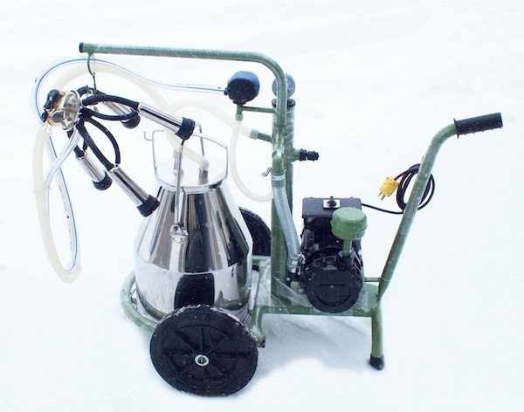
Product Description
In the GreenOak Dairy Equipment Catalogue the part number for a portable milk machine for cattle is 488195. The milk machine costs about $1995 Canadian and can be used for various types of cattle (Singh, 2016). However it is manufactured in the United States (Singh, 2016) and then sold in Canada. It is a very advantageous and profitable way to milk animals when you have a small amount of animals to milk or if the milk needs to be separated when an animal has been treated. What causes the milk to be extracted from the udder is the pulsator mechanism. The pulsator mechanism results in a consistent rhythm of the expansion and collapse of the rubber teat cup during the milking of the cow (Clough, P.A. et. al 1953). Every other time there is limited vacuum used and letting out air between lining of the cup and the teat shell of the cup. The liner is consistently applied with the partial vacuum, which is usually 13-15 in. Hg (Clough, P.A. et. al 1953). The machine itself requires very little maintenance however the treadle must stay greased and free from any debris. The cups of the milking cluster will have to be washed after every milking to keep unnecessary bacteria from going into the milk. Before the operator hooks the milk cluster up to the cow it is necessary to clean the teats with cloth and some sort of disinfecting solution that is present in Nepal.
http://www.greenoakna.com/portable-milkers/
Approximate dimensions of the Portable Milk Machine
Dimensions | Weight | Height | Length | Width
 | 35 kg | 1 m | 1.2m | .5m
Table 1 (De Jong, 2016)

Requirements and Issues
The milk machine requires an electrical source as seen in the image. Only 50% of the Nepalese people have access to an electrical grid (Gurung, 2011). The Nepalese government has been working on distributing and producing many renewable energy technologies, such as micro-hydropower which has been the most likely to be adopted and pledged to provide electricity for the rural parts of Nepal (Gurung, 2011). Micro hydropower is a process from which electricity is created from water, this is a common way in which electricity is created in the rural areas of developing countries (Paish, 2002). As there is being more electricity being created in the rural areas, the milk machine could be used more in the rural areas in the future. However since the milk machine requires an electricity source and there is very little in the rural areas of Nepal it means that it would be best if the machine is purchased by a community of farmers. The milk machine comes with a stainless steel jar and a milk cluster which can just be flushed out with water immediately after use, in order to prevent bacterial growth. The foot powered milk machine can be used all year round, however in the winter when temperatures get to be about 14.5 to 18 degrees by the afternoon it would be nice to be able to use it indoors (Karki, et. al 2016). An advantage of the milk machine is that it isn’t very large therefore can be moved around quite easily so the Nepalese farmer can milk his cattle in the field or wherever he would like (GreenOak Dairy Equipment, 2015).

Canadian benefits
More Canadian jobs
The fact that the milk machine is manufactured in the United States and then shipped to Canada and sold there, it will provide jobs for those working for the businesses. As more portable milk machines are sold there needs to be more milk machines manufactured. Exporting the milk machine starts by manufacturing the machine then also having it put into boxes and then out into shipping containers to prevent damage while travelling.
Promote the business
By exporting the milk machine to Nepal, it will promote GreenOak Dairy Equipment because when the milk machine is purchased by a Nepalese farmer and is profitable for the farmer, other Nepalese farmers will become interested in the product because of the success it is providing for other farmers. As a result it will promote the Canadian product in a positive way, creating business.
Support for exporting the product
The Government has an Agri-Marketing Program which helps various food processors and farmers to challenge the market weather it be locally or globally (OMAFRA, 2016). The government has about $341 million which is available for funding during five years, when a business is involved in the Agri-Marketing Program (OMAFRA, 2016). This program helps the farmers get involved in the market and use the opportunities given (OMAFRA, 2016).

PART 2: POTENTIAL BENEFITS TO NEPAL
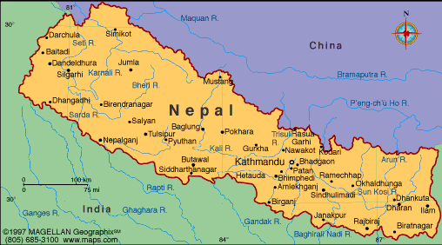
Nepal is a landlocked country and can be split up into three regions: mountains, terai and hills (Rai et al., 2002). The agriculture and forestry sector is what most of the people work in, almost 70% of the population is involved in agriculture or forestry (USAID, 2016). Approximately 13% of the population in Nepal in undernourished, this is a result of agricultural production declining followed by poor rural economies (USAID, 2016). If the farmers gain access to modern farming technologies and become involved in the market then there will be more food produced to sustain the growing population (USAID, 2016).
http://i.infopls.com/images/mnepal.gif

Nepal’s developing milk production industry
Farmers have little herds, cows are mostly milked by hand and the market infrastructure is not very good especially when it comes to giving services and inputs for the Nepalese farmers to order to get the most inputs possible (Singh and Pundir, 2002). In the urban markets in Nepal the demand for dairy products has certainly increased in the past years and will continue to grow seeing as the income for many Nepalese is rising as well as the population of Nepal (FAO, 2008). There was a study done on farming in Nepal, which portrays about 75000 of the farmers in Nepal who market their milk after it is produced (Joshi D.D, 2001). The farmers are payed based on the quality of milk and receive their payment every 15 days (Joshi D.D, 2001). In Nepal, most of the milk production comes from buffalo and dairy cattle (Joshi D.D, 2001) and processed into various dairy products such as cheese and butter (FAO, 2008). Milk as well as milk commodities are a crucial point of the supply of protein in Nepalese diets (Joshi B.R., n.d.).

Benefits for Nepal
The milk machine would help improve Nepalese agriculture in a big way. The milk machine would allow farmers to milk faster, get more milk out of their cows, resulting in an increased income for the farmer. Furthermore, more dairy products could be exported out of Nepal, resulting in the improvement of gross domestic production which would improve the overall life of Nepalese citizens.
Milk production
A farmer in Nepal has an average 3.5 cattle, which makes the milk machine a perfect product for Nepalese farmers to purchase (Joshi D.D, 2001). The milk production per animal is quite low, for buffalo about 854 liters annually and for cows about 440 liters annually (FAO, 2008). As seen in table 2, the main issue is seen by the dairy processors is the lack of local raw milk, the increase in productivity and milk production is critical. There needs to be more milk produced with the population of Nepal increasing at a rate of about 2% per year (FAO, 2008).
 | 1990 Consumption Level | Needs Level
Milk (kg/head) | 46.4 | 57.8
Table 2 (FAO, 2008)
The milk production will increase as a result of using the milk machine because the farmer will be able to milk the cow two or three times a day depending on preference of the farmer. Also, the daily milking will be more consistent using the machine and to produce more milk the farmer can choose to milk the cow more often in a day. When a cow or buffalo is milked with the machine they will be milked out each time which is overall better for the cow’s udder.
Less work
The milk machine will involve much less labour rather than the farmer milking each of their cows by hand. It will also take much less time because all four quarters of the cows udder get milked at once with the milk machine rather than only one or two quarters getting milked by hand at a time.
Beneficial to an entire community
Since the milk machine cost around 1995 Canadian Dollars which is around 201481.80 Nepalese Rupees (Bank of Canada, 2016) it would make the most sense if a milk machine is purchased by a community. This way each farmer in the community pitches in a bit of money to purchase the machine and then they can take turns using it to milk their cattle.
Meet the growing demand for milk
After the milk is processed, the cost of processed milk per liter is 18.32 Nepalese rupees per liter of milk (Joshi D.D, 2008). Which is equal to about $.36 Canadian (Bank of Canada, 2016). The farmers are payed much less for their milk in Nepal then in Canada. Milk consumption is quite popular in the urban areas of Nepal, each family purchases approximately 1.03 liters per day (FAO, 2008). The demand for milk is increasing annually by approximately 2%, this means that the Nepalese farmers need to increase the milk production by at least 2% per year in order to meet milk production demand (FAO, 2008). The milk machine will result in farmers will milk their cattle consistently, this results in the cow feeling less stress then the cow will relax more when feeding and producing milk.
Improve overall nutrition of Nepalese citizens
Nepal is underdeveloped as a result many people suffer from malnutrition which has negative effects on the economy and decreases work rate (Rai et al., 2002). Milk and milk products are very important sources of protein in the Nepalese diet and is an important source of the household income for a Nepalese family (FAO, 2008). Milk contains essential nutrients and is a major source of protein, amino acids, vitamins and minerals which are necessary to stay healthy (Haug et al., 2007). With the increasing population of Nepal it is necessary for farmers to produce more milk in order to sustain the nutrition of the population. The use of the milk machine can have the potential of making dairy products more affordable and accessible for Nepalese people because of the increased demand, which would result in an overall improvement of the health.
Dairy exports from Nepal
Livestock exports is approximately 64% percent of the total exports, which earned an overall amount of 1.6 million rupees in 1987 and 1988 (Joshi B.P., n.d). The primary products exported from Nepal includes the dairy product ghee, various hides and skins as well as live animals (Joshi B.P., n.d). Most of the commodities are exported to India, except for the cattle hides are exported to Europe (Joshi B.P., n.d). Ghee is basically churned butter which I the most valuable product sold in about 8500 metric tonnes exported annually to India, having a value of 595 rupees (Joshi B.P., n.d). If Nepal can significantly boost milk production with farmers using the portable milk machine, they would be able to export milk, ghee and possibly other dairy products, as well as further the milk profit for the farmers and milk processors.

Quantities and Costs of exporting the product
The portable milk machine costs $1995 Canadian (Singh, 2016). Transporting the product to Nepal will be quite expensive and will not be easy. For one portable milking machine to be shipped it will cost $1800 via UPS (UPS, 2016) and A1 freight forwarding cargo shipping (A1 Freight Forwarding, 2016). This price is based on the weight and dimensions of the portable milk machine as seen in table 1. Most of the cattle and buffalo live in the hills and mountains (Joshi, D.D., n.d) which means it would make the most sense to have the milk machine be shipped to that part of Nepal. That way multiple farmers in the same community can use it, depending when each farmer chooses to milk their cattle in a day. It would be the most realistic to export about 5-10 milking machines annually because of the cost of transportation and the cost of the milk machine.
The milk machines stay in the packaging and are then loaded into the UPS truck and then transported to Vancouver.
Portable Milk Machines come from being manufactured in the US to GreenOak Dairy Equipment in Kitchener, ON, Canada.
At the coast the machines are loaded into crates and put onto a cargo boat via A1 freight shipping.

The ship will unload in Quanshou, China. The boxes will then be taken by a truck to Kathmandu, to the Dairy Development Corporation (DDC). Here they will decide which regions will benefit the most from the milk machines (Uotila et al., 1994).
The portable milk machines will then be transported from Katmandu to the chosen destination by the DDC with a smaller vehicle, then assembled there.

Challenges of exporting to Nepal

There have been several milk machine patented in the past, however there have been many milk machines created since than that have been slightly improved each time so there is really no patent property constraint that can limit the export of the milk machine.
Absence of foundation in market
The current high costs of milk production is a result of the increasing cost of inputs and lack of improved technologies which are needed in order to evaluate the money farmers are spending in order to produce milk and then seeing how that relates to the price of milk.
Poverty
Around 40% of the population in Nepal lives in poverty (Joshi D.D., 2001). An average Nepalese family will earn approximately $210 US in gross national product in a year, which is about 14389.53 rupees (Bank of Canada, 2016). The shipping and cost of the milk machine is very expensive coming to a total of about $3975 Canadian which is equal to approximately 201481.80 rupees (Bank of Canada, 2016). It will take one farmer over a decade to be able to afford one milking machine, therefore it would be better if multiple farmers purchase one portable milk machine together.
Scarcity of Agriculture education
The fact that so many farmers lack the ability to read and live in poverty is restricting their ability to communicate and get involved in the market because they are not able to read, this results in complications in the process (FAO, 2008). About 59% of males and 86% of females unable to read, the fact that farmers can’t read can sometimes result in them missing market opportunities which can sometimes be costly for the farmer (FAO, 2008).
Transport of Product to Farmers in faraway Areas
The roads in Nepal are not very good so it will be difficult for transportation to gain access to the farmers in order to deliver the milk machines (Donnges, 2005). However the milk machine does have wheels on it so it is possible for the farmer to pick up the milk machine at the closest location to the farm and then carefully wheel the milk machine to the farm.
Trade barriers
Nepal is very open and depends on trade, however it has not been very productive in making the trade competitiveness improve (Pant, 2005). Nepal is a member of the World Trade Organization, however they need to become a more competitive in the trading sector by being dependable with being involved in multiple trade agreements (Pant, 2005).

Regional and Global Competition
There are many different companies located throughout the world that sell portable milk machines. There are several companies in Canada which GreenOak has competition with for example, Norwell Dairy and DeLaval. Consequently there will be competition for portable milk machines, today there are many milk machines being shipped to Nepal from various countries. For example Pro Equipment Supplier Pvt Ltd is located in Kathmandu, Nepal and is a trading company specifically for farming products such as milk machines ad cow mats (Alibaba, 2016). This can result in serious competition for the Canadian company especially since they get it from the U.S. for around $1200 Canadian (Bank of Canada, 2016) which is already much cheaper then what GreenOak sells it for.

Recommendations for export and Future Studies
There will definitely have to be more studies done to look at the electricity necessities as well as which communities produce electricity and if so, how much. An important part of improving step needed in order to improve agriculture would improving educating farmers about the agriculture technology that is being imported. In order to keep the transporting costs low the rural areas should be split up based on what the farmers need so the product can be shipped in batches. GreenOak Dairy should look into having the portable milk machines be produced less technologically advanced, so it can be used in the rural parts of Nepal.

References
Alibaba. (2016). The Milking Machine. Retrieved November 26, 2016 from: https://www.alibaba.com/countrysearch/NP/the-milking-machine-supplier.html
A1 Freight Forwarding. (2016). Free Instant Quote. Retrieved November 26, 2016 from: http://www.a1freightforwarding.com/quick-quote/
Bank of Canada. (2016). Daily Currency Converter. Retrieved November 26, 2016 from: http://www.bankofcanada.ca/rates/exchange/daily-converter/
Clough, P.A., Dodd, F.H. and Hughes, E.W. (1953) ‘529. Pulsation and milking rate’,Journal of Dairy Research, 20(3), pp. 375–380.
De Jong, Kirsten. (2016). Measurements of milk machine.
Donnges, C. (2005). Integrated rural accessibility planning in Nepal. Nepal: International Labour Organization.
FAO. (2008). Dairy Sector Study of Nepal. Retrieved November 26, 2016 from: ftp://ftp.fao.org/TC/CPF/Country%20NMTPF/Nepal/thematic%20studies/Dairy.pdf

GreenOak Dairy Equipment (2015). Portable Milkers are back. Retrieved November 26, 2016 from: http://www.greenoakna.com/portable-milkers/
Gurung, A., Gurung, O. P., & Oh, S. E. (2011). The potential of a renewable energy technology for rural electrification in Nepal: A case study from tangting. Renewable Energy, 36(11), 3203- 3210.
Haug, A., Høstmark, A. T., & Harstad, O. M. (2007). Bovine milk in human nutrition–a review. Lipids in health and disease, 6(1), 1.
IFCN (International Farm Comparison Network). (2014). Dairy report 2014. (IFCN Publication). Germany:IFCN.
Joshi, B. R. (n. d.) The role of large ruminants. Nepal: FAO.
Joshi, D. D. (2001). Farmers' perceptions of service delivery and policy support from smallholder dairy in Nepal: Nepal case study.
Karki, Ramchandra; Talchabhadel, Rocky; Aalto, Juha; Baidya, Saraj, Kumar (2016). "New Climatic Classification of Nepal." Theoretical and Applied Climatology 125.3-4: 799- 808.
OMAFRA. (2016). AgriMarketing Program. Retrieved November 26, 2016 from: http://www.agr.gc.ca/eng/?id=1357941192614.
Paish, O. (2002). Micro-hydropower: status and prospects. Proceedings of the Institution of \Mechanical Engineers, Part A: Journal of Power and Energy, 216(1), 31-40.
Pant, B. (2005). Nepal’s Trade Sector: Review, Repercussions and Recommendations. Economic Review, 17, 89-115.
Rai, S. K., Hirai, K., Abe, A., & Ohno, Y. (2002). Infectious diseases and malnutrition status in Nepal: an overview. Mal J Nutr, 8(2), 191-200. (Rai et al., 2002)
Singh, K., & Pundir, R. S. (2002). Problems and prospects of smallholder dairy production and marketing in south asia: An overview. India: International Livestock Research Institute.
Singh, S. (2016). Sandra Singh: Secretary at GreenOak Dairy Equipment. Interview. 11/25/2016
Uotila, M., & Dhanapala, S. B. (1994). Dairy development through cooperative structure. World Animal Review, 79(2), 16-22.
UPS. (2016). Calculate Time and Cost. Retrieved November 26, 2016 from: https://wwwapps.ups.com/calTimeCost?loc=en_CA&WT.svl=PNRO_L1
USAID. (2016). Agriculture and Food Security | Nepal | U.S. Agency for International Development. Retrieved: from https://www.usaid.gov/nepal/agriculture-and-food- security

